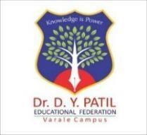 | Dr. D. Y. Patil Educational Federation’s  Dr. D. Y. PATIL COLLEGE OF ENGINEERING & INNOVATION  (An Autonomous Institute Affiliated to SPPU)  Survey No. 27/A/1/2C, Varale Campus, Near Talegaon Railway Station, Tal. Maval, Dist. Pune 410 507, Ph: 020 48522561, 565,566  Web Site: www.dypcoei.edu.in, Email: principal.dypcoei@dypatilef.com | 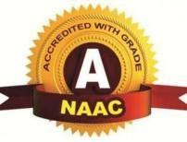

ACTIVITY REPORT ON IDEA TO MARKET: A JOURNEY OF NEWBORN ENTREPRENEURS
Organized By: Incubation Centre / E-Cell, DYPCOEI

Event Details
• Event: Idea to Market: A Journey of Newborn Entrepreneurs
• Date: 24 August 2026
• Time: 11:00 AM – 1:05 PM
• Mode: Offline
• Venue: Seminar Hall / Room No. 206, DYPCOEI
• Type of Activity: Entrepreneurship, Innovation and Student Project Showcase
• Organized By: Incubation Centre / E-Cell, DYPCOEI
• Chief Guest: Adv. Anuja Patil Ma’am
• Guest of Honour: Mr. Jatin Mehrotra Sir
• Principal: Dr. Suresh Mali Sir

Objectives
The “Idea to Market: A Journey of Newborn Entrepreneurs” event was organized with the following objectives:
- To introduce students to the activities and opportunities provided by the Incubation Centre.
- To introduce students to the E-Cell and its role in promoting entrepreneurship.
- To encourage innovation and entrepreneurial thinking among students.
- To provide a platform for students to showcase their practical projects.
- To demonstrate how technical ideas can be developed into useful products and services.
- To recognize and motivate students involved in incubation and entrepreneurship activities.
- To encourage students to explore entrepreneurship as a career and innovation as a means of solving real-world problems.

Event Summary
The Idea to Market: A Journey of Newborn Entrepreneurs event was conducted on 24 August 2026 at Seminar Hall / Room No. 206, DYPCOEI. The programme commenced at 11:00 AM with the welcome of the distinguished guests. The Chief Guest, Adv. Anuja Patil Ma’am, Guest of Honour, Mr. Jatin Mehrotra Sir, and Principal Dr. Suresh Mali Sir were formally welcomed by the student volunteers.
The inaugural ceremony was followed by Ceremonial Lamp Lighting and Saraswati Vandana, marking the formal beginning of the programme.
The event then focused on introducing students to the Incubation Centre and E-Cell, followed by a live showcase of projects developed by incubation centre students.

Introduction to the Incubation Centre and E-Cell
An introductory session on the Incubation Centre and E-Cell was conducted as an important part of the programme.
The session familiarized students with the purpose and activities of these platforms and highlighted the opportunities available for students interested in innovation, entrepreneurship, project development, and startup-oriented activities.
The session was conducted by the Incubation Centre Coordinator and E-Cell President.

Live Project Showcase

A major highlight of the event was the Live Project Showcase by Incubation Centre Students.

Four project groups presented their projects:

a) Product Development – Canteen Pre-Order

The project focused on product development in the area of canteen pre-ordering, demonstrating how technology can be used to improve the process of ordering food and managing canteen services.

b) SEO – Funeral Services

The project demonstrated the application of Search Engine Optimization (SEO) for funeral services, highlighting the use of digital platforms to improve online visibility and accessibility.

c) App Development – Pandit App

The students showcased an application-based solution named Pandit App, demonstrating the development of a digital platform through mobile application technology.

d) Website Development

The students presented their work in website development, demonstrating how web technologies can be used to create practical digital solutions.

The live showcase provided students with an opportunity to present their work and demonstrate the practical application of their technical knowledge

Certificate Distribution Ceremony

The event included a Certificate Distribution Ceremony to recognize the efforts and participation of students.

Certificates were distributed to:

Incubation Centre Students – 3 Groups

Eureka Event – 3 Groups

The certificates were presented in the presence of the Chief Guest, Guest of Honour, and dignitaries, providing recognition and encouragement to the participating students.

7. Addresses by the Dignitaries

The programme included addresses by the institute's dignitaries and guests.

Address by the Principal

Dr. Suresh Mali Sir, Principal, DYP COEI, addressed the gathering and shared his thoughts with the students.

Address by the Guest of Honour

Mr. Jatin Mehrotra Sir, Guest of Honour, addressed the students and shared his valuable insights and guidance.

Address by the Chief Guest

Adv. Anuja Patil Ma’am, Chief Guest, addressed the gathering and motivated students towards innovation, entrepreneurship, and the development of their ideas.

These addresses added an inspirational and motivational dimension to the programme.

8. Conduct of the Event

The event followed a structured programme beginning with the welcome ceremony and inauguration. It then progressed through the introduction of the Incubation Centre and E-Cell, followed by the live project showcase.

The certificate distribution ceremony provided recognition to participating students, after which the Principal, Guest of Honour, and Chief Guest addressed the gathering.

The programme concluded with a Vote of Thanks and Group Photograph conducted by the Incubation Team / E-Cell Team.

9. Outcomes of the Event
Exposure to Entrepreneurship
The event provided students with exposure to the concepts of incubation, entrepreneurship, and the journey of developing an idea into a practical solution.
Project Showcase Experience
Students received an opportunity to publicly showcase their projects and demonstrate their technical and creative capabilities.
Awareness of Incubation Opportunities
The introduction to the Incubation Centre helped students understand the opportunities available for developing innovative ideas and projects.
Promotion of Innovation
The event encouraged students to think beyond academics and explore innovative solutions to practical requirements.
Recognition of Student Efforts
The certificate distribution ceremony acknowledged student participation and encouraged continued involvement in incubation and entrepreneurship activities.
Motivation for Future Entrepreneurs
The interaction with dignitaries and the presentation of student projects provided motivation for students interested in developing their ideas and pursuing entrepreneurial opportunities.

10. Conclusion
The “Idea to Market: A Journey of Newborn Entrepreneurs” event successfully provided a platform for students to learn about the Incubation Centre and E-Cell, witness innovative student projects, and gain exposure to entrepreneurship and product development.
The live project showcase featuring Canteen Pre-Order, SEO – Funeral Services, Pandit App, and Website Development demonstrated the diverse ways in which students are applying their technical knowledge to practical ideas.
The certificate distribution further recognized student efforts, while the addresses by the Principal, Guest of Honour, and Chief Guest added valuable motivation and guidance.
Overall, the event reinforced the importance of innovation, practical project development, entrepreneurship, and transforming ideas into meaningful solutions, contributing towards building an entrepreneurial culture among students at DYPCOEI.

11. Glimpses

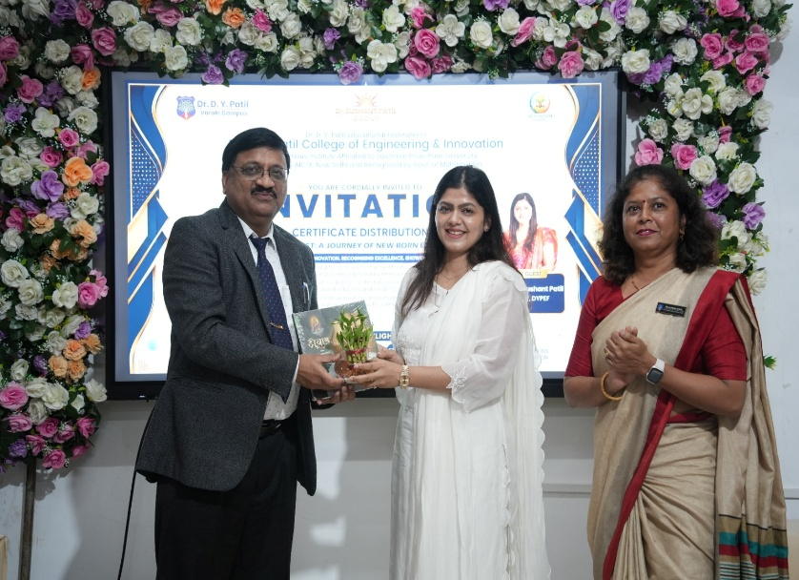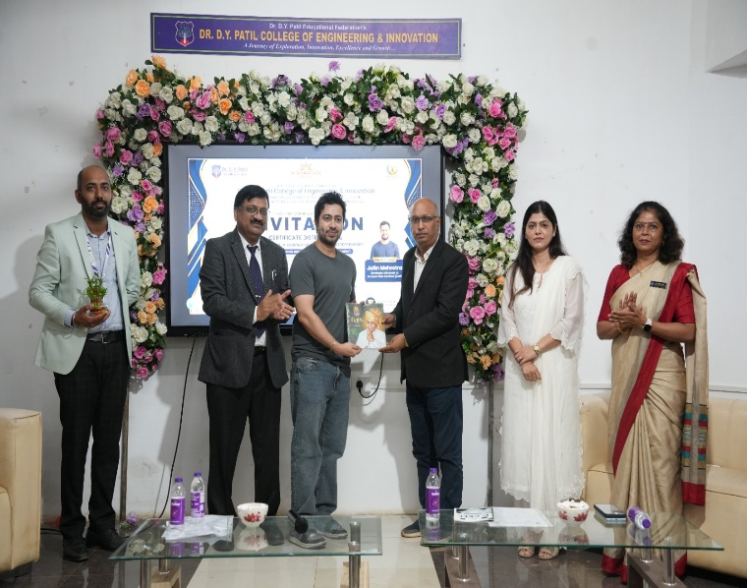
Figure 1: Welcome of the Chief Guest, Guest of Honour and Principal

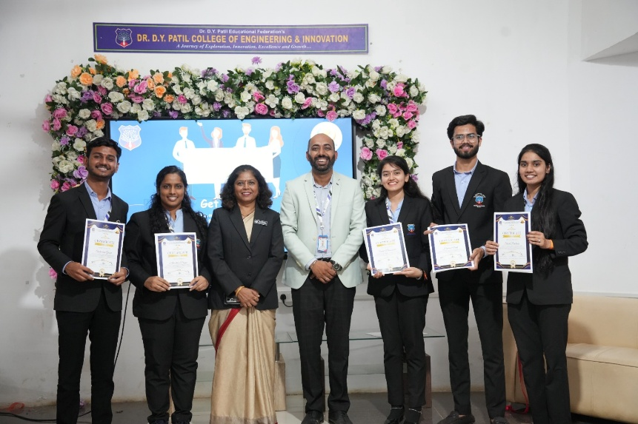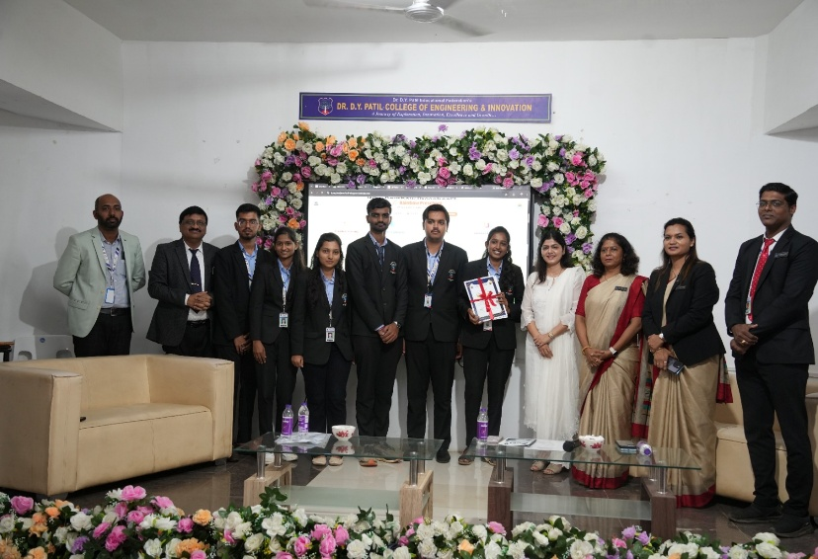

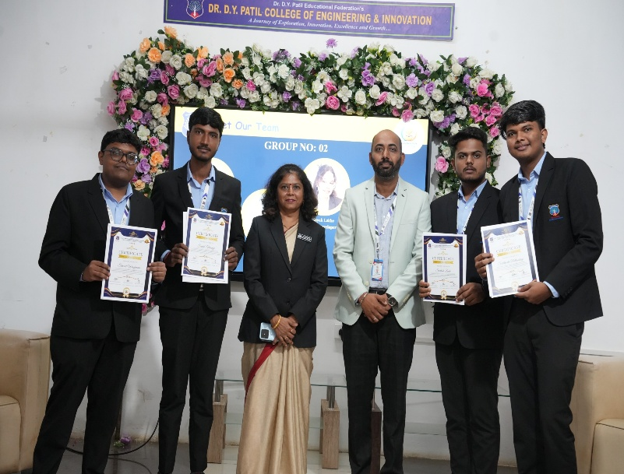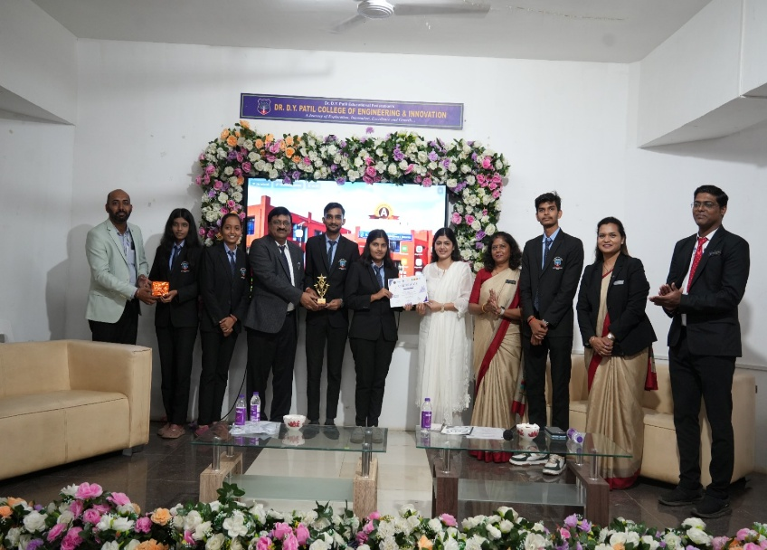
Figure 2: Certificate Distribution Ceremony
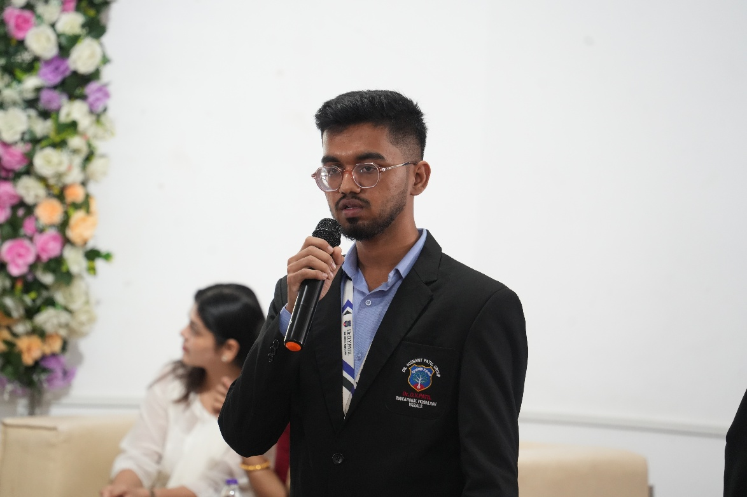
Figure 3: Canteen Pre-Order / Product Development Project Presentation

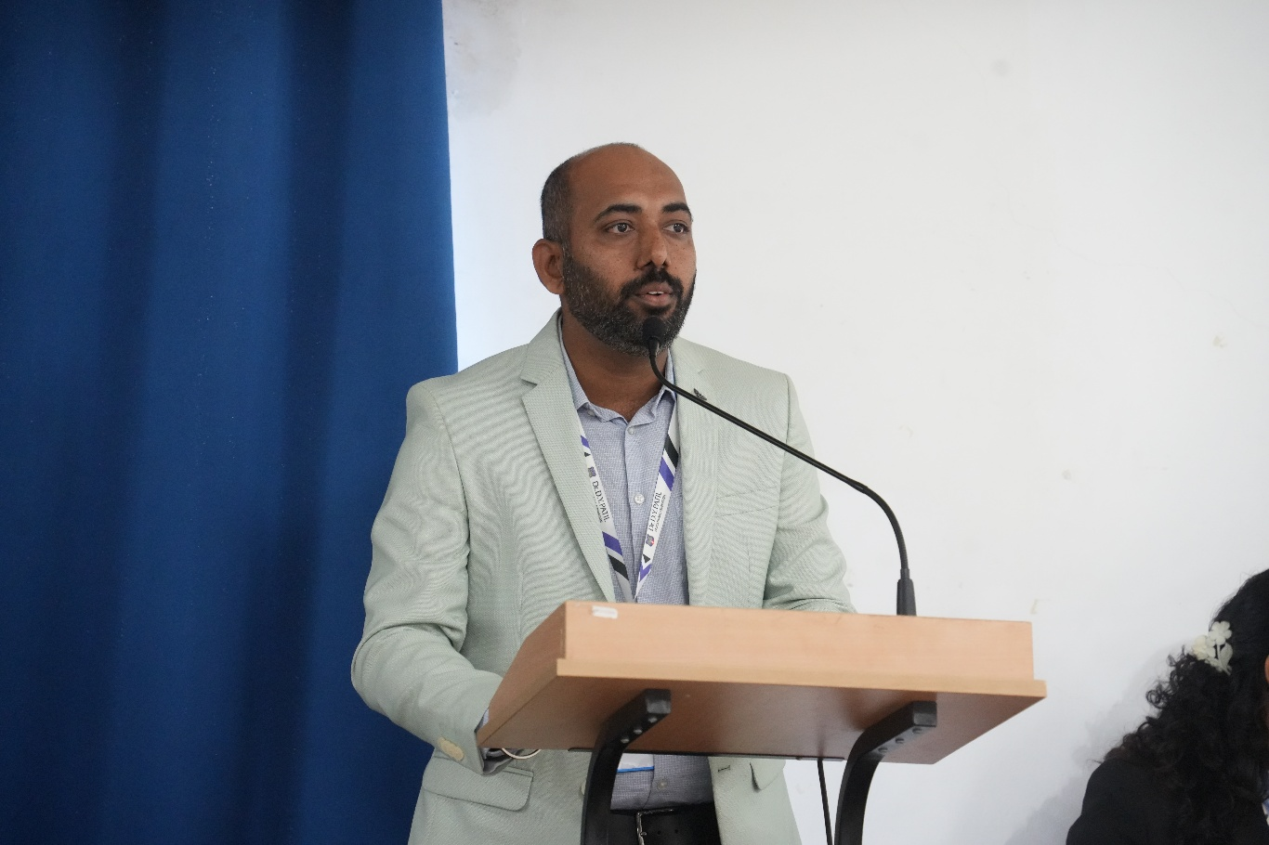

Figure 4: Introduction to the Incubation Centre
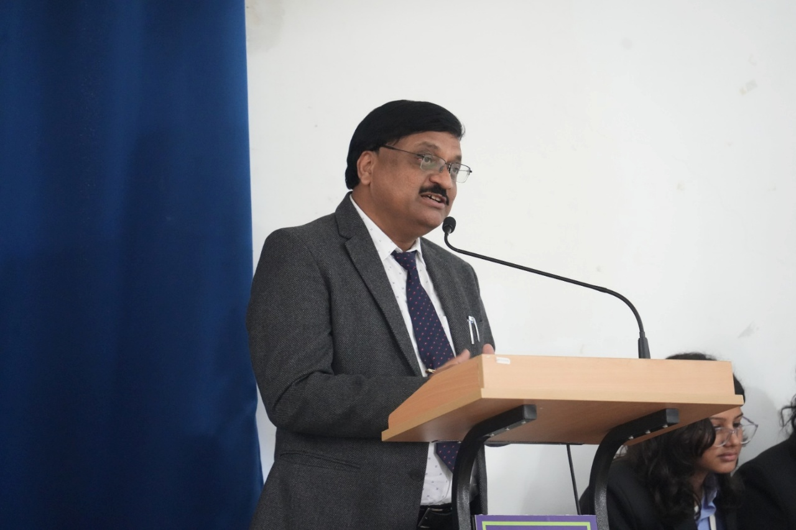
Figure 5: Address by the Principal

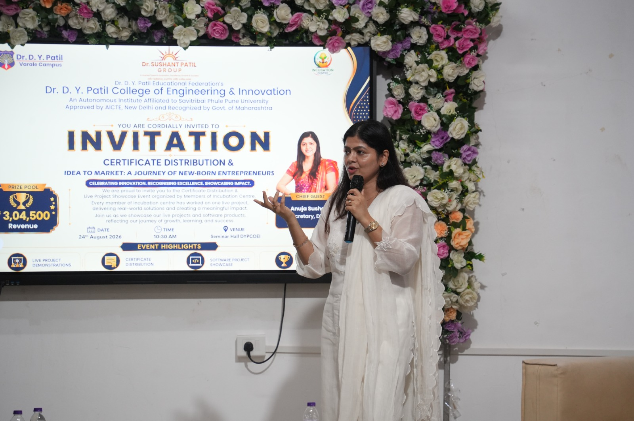
Figure 6: Address by the Guest of Honour
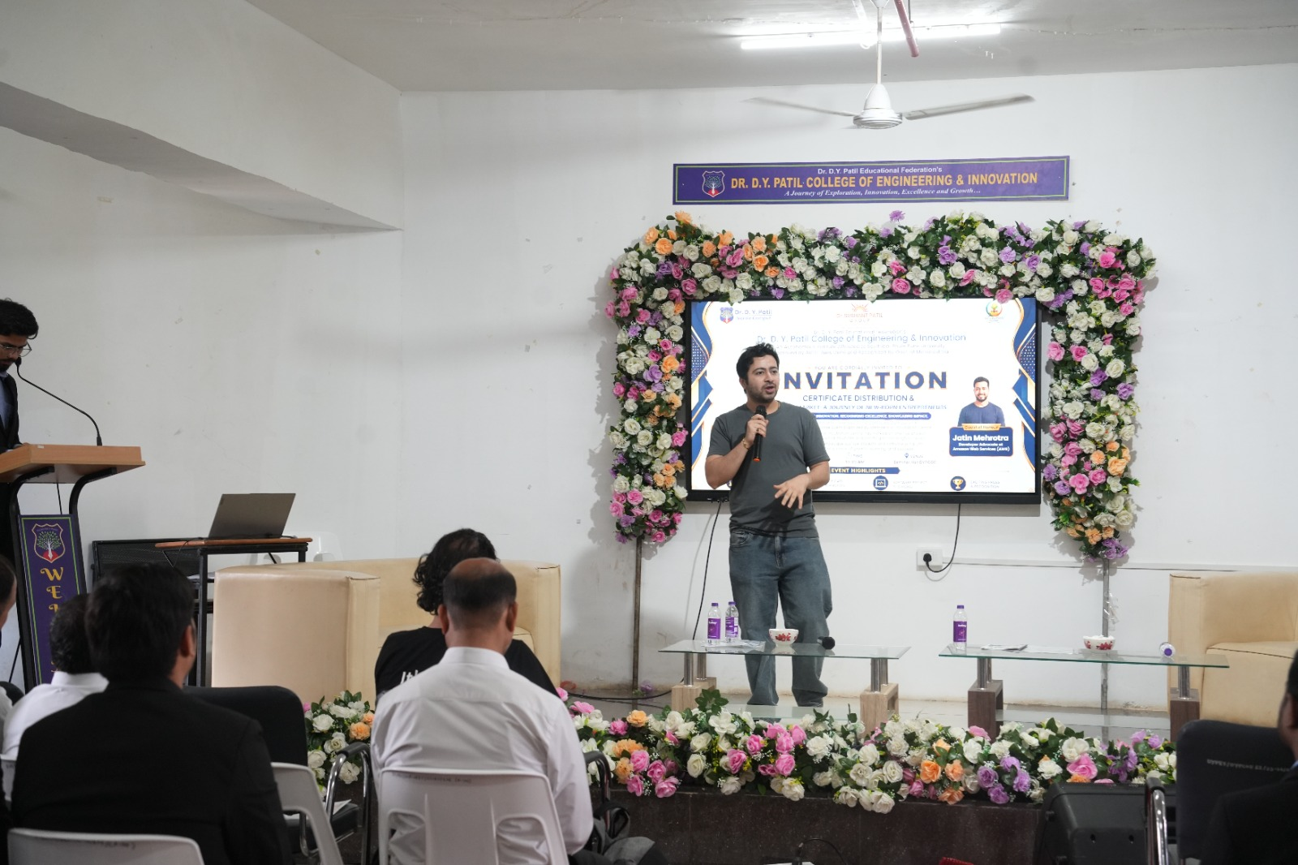
Figure 7: Address by the Chief Guest

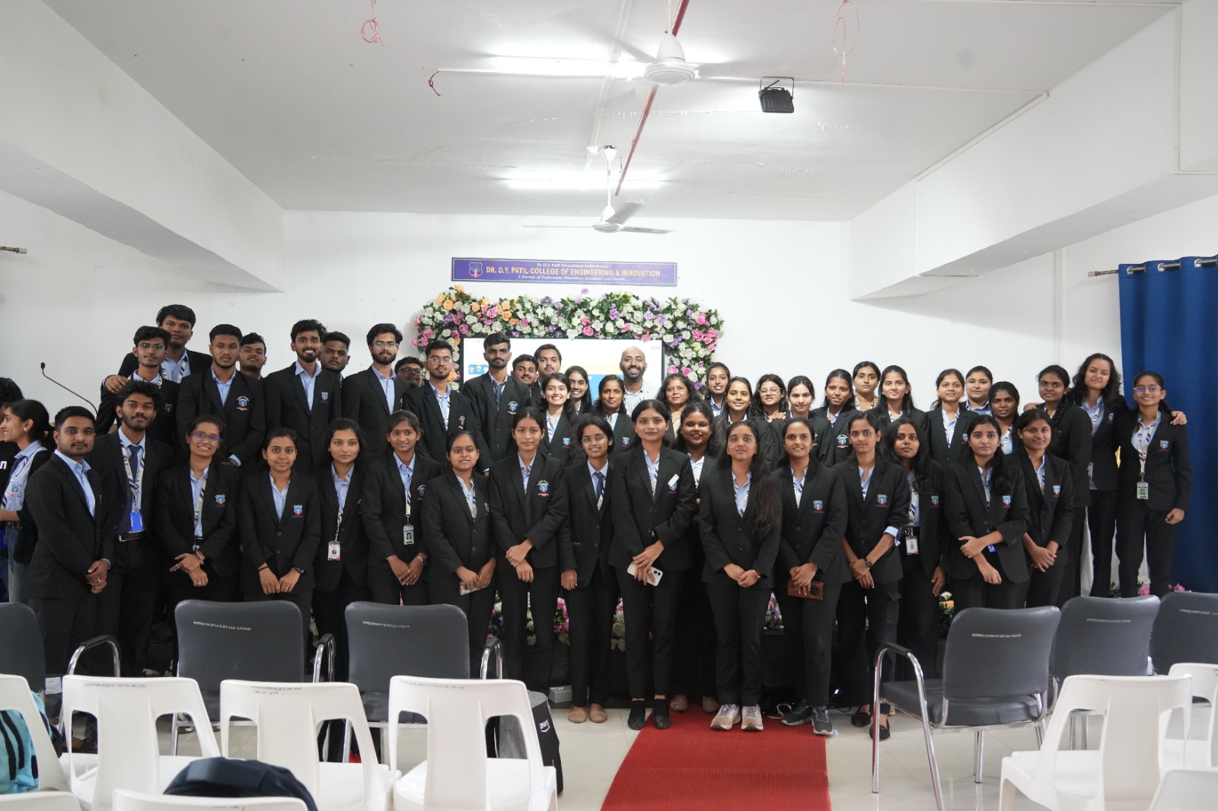
Figure 8: Group Photo of Incubation Centre Members
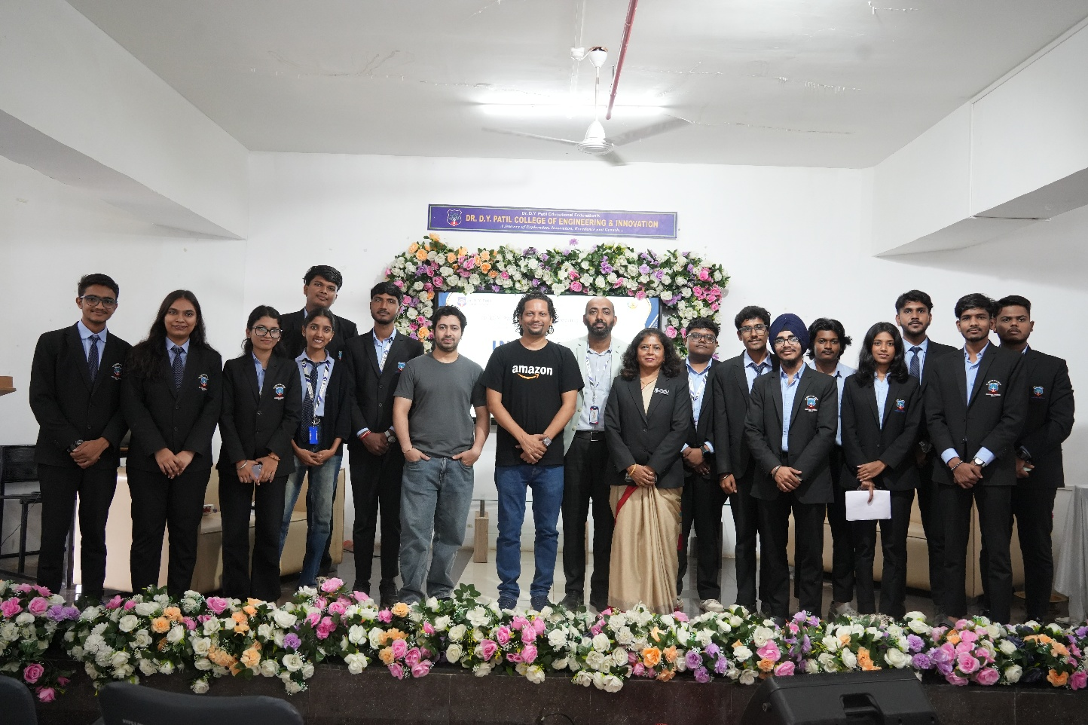
Figure 9: Group Photo of E-Cell Members

Mr. Swami Panjala | Dr. Alpana Adsul | Dr. Suresh Mali
Faculty Coordinator | HOD COMP | Principal

